**1. Retrieve all weather data for Houston**

Select * From weatherdatabase.`texas daily weather data 2022`

Where City_Name = "Houston";

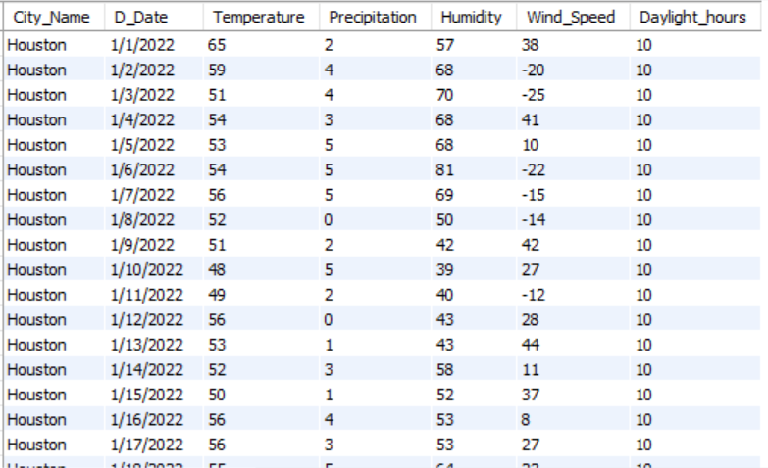

**2. Get the average temperature for Dallas**

select avg(temperature) from weatherdatabase.`texas daily weather data 2022`

where City_Name = "Dallas";

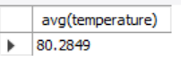

**3. Find the maximum temperature in Texas recorded on 8/8/2022**

select max(temperature) from weatherdatabase.`texas daily weather data 2022`

where Date = "8/8/2022";

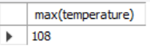

**4. Retrieve weather data for the month of July**

Select*from weatherdatabase.`texas daily weather data 2022`

where Date like "%/7/%";

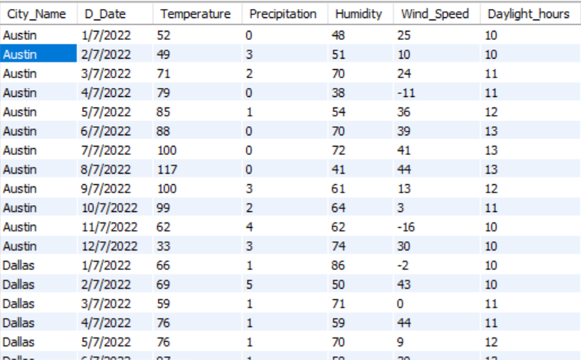

**5. Find the average humidity in Texas for the month of February**

Select avg(Humidity) as Average_Humidity

from weatherdatabase.`texas daily weather data 2022`

Where D_Date like "%/2/%";

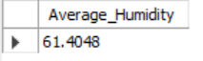

**6. Retrieve the weather data for the hottest day**

SELECT * FROM weatherdatabase.`texas daily weather data 2022`

WHERE temperature = (SELECT MAX(temperature) FROM weatherdatabase.`texas daily weather data 2022`);



**7. Get the number of days with precipitation above 1 inches in San Antonio**

select count(*) as “The Precip_Number”

from weatherdatabase.`nton daily weather data 2022`

where Precipitation > 1 and city_name = “san ntonio”;

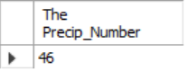

**8. Find the date with the lowest humidity for Midland**

select D_Date as Lowest_Humidity_Date from weatherdatabase.`texas daily weather data 2022`

where city_name = "Midland"

order by Humidity asc limit 1;



**9. Retrieve the average temperature for each city**

select City_Name, avg(temperature) from weatherdatabase.`texas daily weather data 2022`

group by City_Name;

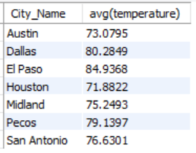

**10. Retrieve weather data for Pecos on 7/15/2022**

select city_name, d_date, temperature, humidity, wind_speed, Daylight_hours

from weatherdatabase.`texas daily weather data 2022`

where d_date = "7/15/2022" and city_name = "Pecos";



**11. Get the average temperature, precipitation, humidity, wind speed, and daylight hours for Houston**

select City_Name,

AVG(Temperature) AS Avg_Temperature,

AVG(Precipitation) AS Avg_Precipitation,

AVG(Humidity) AS Avg_Humidity,

AVG(Wind_Speed) AS Avg_Wind_Speed,

AVG(Daylight_Hours) AS Avg_Daylight_Hours

from weatherdatabase.`texas daily weather data 2022`

where City_Name = "Houston"

group by city_name;



**12. Find the days with the highest precipitation for each city**

SELECT City_Name, D_Date, Precipitation

FROM (

SELECT City_Name, D_Date, Precipitation,

ROW_NUMBER() OVER (PARTITION BY City_Name ORDER BY Precipitation DESC) AS rn

FROM weatherdatabase.`texas daily weather data 2022`

) ranked

WHERE rn = 1;

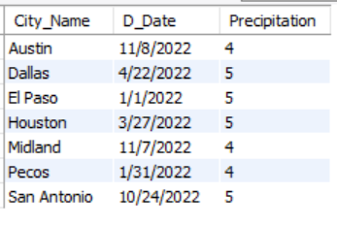

**13. Calculate the total precipitation for each city in January**

select city_name, sum(precipitation) as Total_Precipitation

from weatherdatabase.`texas daily weather data 2022`

where d_date like "%/1/%"

group by city_name;

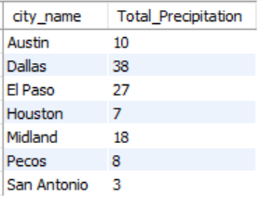

**14. Retrieve the date and temperature for the coldest day in each city**

SELECT City_Name, D_Date, Temperature

FROM (

SELECT City_Name, D_Date, Temperature,

ROW_NUMBER() OVER (PARTITION BY City_Name ORDER BY Temperature asc) AS rn

FROM weatherdatabase.`texas daily weather data 2022`

) ranked

WHERE rn = 1;

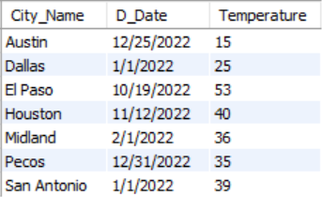

**15. Find the average humidity and wind speed for each city in 2022**

select city_name, avg(humidity) as Avg_Humidity, avg(wind_speed) as Avg_Wind_Speed

from weatherdatabase.`texas daily weather data 2022`

where d_date like "%2022"

group by City_Name;

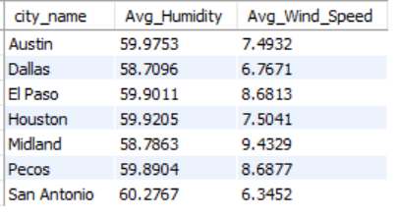

**16. Retrieve the date and daylight hours for the day with the longest daylight in each city**

SELECT City_Name, D_Date, Daylight_Hours

FROM (

SELECT City_Name, D_Date, Daylight_Hours,

ROW_NUMBER() OVER (PARTITION BY City_Name ORDER BY Daylight_Hours DESC) AS rn

FROM weatherdatabase.`texas daily weather data 2022`

) ranked

WHERE rn = 1;

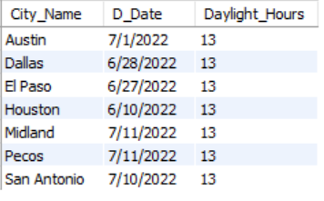

**17. Get the maximum temperature recorded for each city**

select city_name, max(temperature) as Max_Temperature

from weatherdatabase.`texas daily weather data 2022`

group by City_Name;

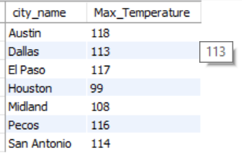

**18. Find the cities where the temperature exceeded 90 degrees Fahrenheit on 8/15/2022**

SELECT City_Name

FROM weatherdatabase.`texas daily weather data 2022`

WHERE Temperature > 90 AND D_Date = '8/15/2022';

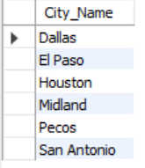

**19. Retrieve the date and precipitation for days with significant rainfall (more than 0.5 inches) for Houston**

SELECT City_Name, D_Date, Precipitation

FROM weatherdatabase.`texas daily weather data 2022`

WHERE City_Name = 'Houston' AND Precipitation > 0.5;

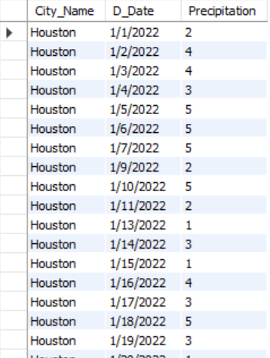

**20. Retrieve the date and wind speed for the windiest day in each city**

SELECT City_Name, D_Date, Wind_Speed

FROM (

SELECT City_Name, D_Date, Wind_Speed,

ROW_NUMBER() OVER (PARTITION BY City_Name ORDER BY Wind_Speed DESC) AS rn

FROM weatherdatabase.`texas daily weather data 2022`

) ranked

WHERE rn = 1;

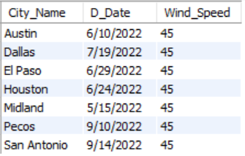

**21. Find the cities where it rained on consecutive days (at least two days in a row)**

SELECT DISTINCT w1.City_Name

FROM weatherdatabase.`texas daily weather data 2022` w1

JOIN weatherdatabase.`texas daily weather data 2022` w2 ON w1.City_Name = w2.City_Name AND w2.D_Date - w1.D_Date = 1

WHERE w1.Precipitation > 0 AND w2.Precipitation > 0;

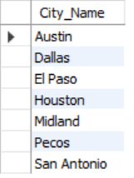

**22. Get the date and daylight hours for the shortest day in each city**

SELECT City_Name, D_Date, Daylight_Hours

FROM (

SELECT City_Name, D_Date, Daylight_Hours,

ROW_NUMBER() OVER (PARTITION BY City_Name ORDER BY Daylight_Hours ASC) AS rn

FROM weatherdatabase.`texas daily weather data 2022`

) ranked

WHERE rn = 1;

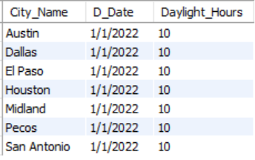

**23. Retrieve the date and temperature for days when the temperature increased by more than 10 degrees Fahrenheit compared to the previous day**

SELECT w1.City_Name, w1.D_Date, w1.Temperature

FROM weatherdatabase.`texas daily weather data 2022` w1

JOIN weatherdatabase.`texas daily weather data 2022` w2 ON w1.City_Name = w2.City_Name AND w1.D_Date - w2.D_Date = 1

WHERE w1.Temperature - w2.Temperature > 10;

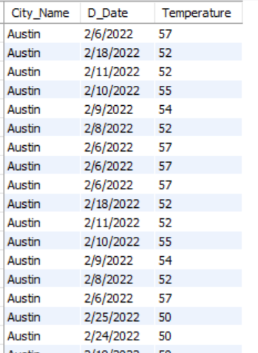

**24. Find the cities where the temperature was within 5 degrees Fahrenheit of the average temperature for the entire dataset on 3.7.2022**

SELECT w.City_Name

FROM weatherdatabase.`texas daily weather data 2022` w

JOIN (

SELECT AVG(Temperature) AS avg_temp

FROM weatherdatabase.`texas daily weather data 2022`

) AS avg_temps

WHERE ABS(w.Temperature - avg_temps.avg_temp) <= 5

AND w.D_Date = '3/7/2022';



**25. Calculate the average temperature for each city, considering only days when it rained**

SELECT City_Name, AVG(Temperature) AS Avg_Temperature

FROM weatherdatabase.`texas daily weather data 2022`

WHERE Precipitation > 0

GROUP BY City_Name

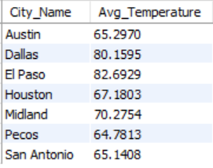

**26. Retrieve the date and humidity for days when the humidity was above 80% in Houston**

SELECT City_Name, D_Date, Humidity

FROM weatherdatabase.`texas daily weather data 2022`

WHERE City_Name = 'Houston' AND Humidity > 80;

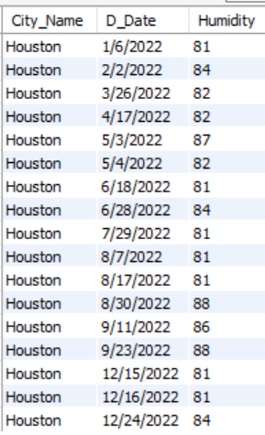

**27. Get the highest temperature and corresponding date for each city**

SELECT City_Name, D_Date, Temperature

FROM (

SELECT City_Name, D_Date, Temperature,

ROW_NUMBER() OVER (PARTITION BY City_Name ORDER BY Temperature DESC) AS rn

FROM weatherdatabase.`texas daily weather data 2022`

) ranked

WHERE rn = 1;

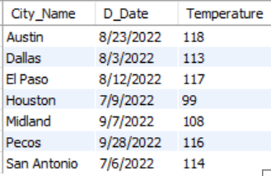

**28. Find the cities where it was sunny (no precipitation) and windy (wind speed above 10 mph) on 2/24/2022**

SELECT DISTINCT w.City_Name

FROM weatherdatabase.`texas daily weather data 2022` w

WHERE w.Precipitation < 0.2 AND w.Wind_Speed > 10 AND w.D_Date = '2/24/2022';

